40.33: For an excited level of the harmonic oscillator
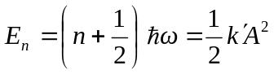
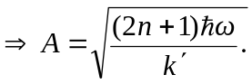 This is the uncertainty in the position.
Also 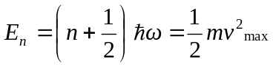
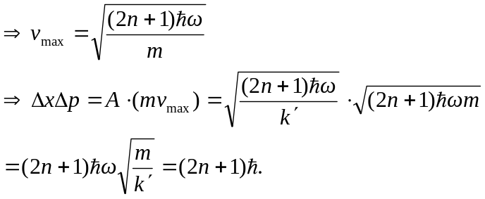
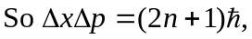 which agrees for the ground state 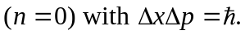
The uncertainty is seen to increase with n.

